**POORNIMA UNIVERSITY, JAIPUR**

**END SEMESTER EXAMINATION, APRIL 2023**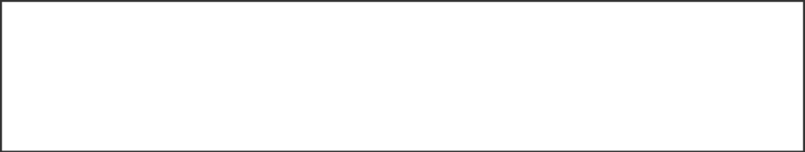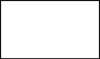

|  |  |  |  |
| --- | --- | --- | --- |
|  | **3BT6117** | Roll No. | Total Printed Pages: 1 |
| **3BT6117** |  |
| B. Tech. III Year VI- Semester (Main/Back) End Semester Examination, April 2023  **(CE/CC)** | |
| **BCE06101 / BCC06101 : Computer Graphics** | | | |

# Time: **3** Hours. Total Marks: **60**

Min. Passing Marks: **21**

*Attempt* ***five*** *questions selecting one question from each Unit. There is internal choice from Unit I to Unit V. Marks of each question or its parts are indicated against each question / parts. Draw neat sketches wherever necessary to illustrate the answer. Assume missing data suitably (if any) and clearly indicate the same in the answer.*

Use of following supporting material is permitted during examination for this subject.

# **1.--------------------------Nil--------------------** **2.------------------Nil-----------------------**

|  |  |  |  |
| --- | --- | --- | --- |
|  |  |  |  |

|  |  |  |  |  |
| --- | --- | --- | --- | --- |
|  |  | **UNIT-I (CO1)** | **Marks** | **Bloom Level** |
| **Q.1** | **(a)** | Differentiate Raster scan and Random scan Display. Explain Video display Devices in brief. | **(6)** | **Analyze** |
|  |  |  |  |  |
|  | **(b)** | What do you mean by Computer Graphics? How it can helps in modern era? | **(6)** | **Remember** |
|  |  | **OR** |  |  |
| **Q.2** | **(a)** | Explain Bresenham’s Mid-point line drawing algorithm with suitable example. | **(6)** | **Understand** |
|  |  |  |  |  |
|  | **(b)** | What do you mean by Frame Buffer? Explain Input Devices used in Computer Graphics. | **(6)** | **Remember** |
|  |  | **UNIT-II (CO2)** |  |  |
| **Q.3** | **(a)** | Design a line using Cohen-Sutherland Line Clipping Algorithm. | **(6)** | **Create** |
|  |  |  |  |  |
|  | **(b)** | What do you understand by 2-D Viewing transformation Pipeline? Explain Window-to-Viewpoint Coordinate Transformations. | **(6)** | **Understand** |
|  |  | **OR** |  |  |
| **Q.4** | **(a)** | Describe Curve Clipping And Text Clipping. | **(6)** | **Understand** |
|  |  |  |  |  |
|  | **(b)** | Design a polygon clipping using Sutherland-Hodgeman Polygon Clipping. | **(6)** | **Create** |
|  |  | **UNIT-III (CO3)** |  |  |
| **Q.5** | **(a)** | Demonstrate the 3-DTransformation in the area of computer graphics. | **(6)** | **Apply** |
|  |  |  |  |  |
|  | **(b)** | How can we recognize Filled Area Primitives? Explain its types and Scan Line Polygon Filling Algorithm. | **(6)** | **Understand** |
|  |  | **OR** |  |  |
| **Q.6** | **(a)** | Define the use of 3-D Projections in computer graphics. | **(6)** | **Remember** |
|  |  |  |  |  |
|  | **(b)** | Explain the Boundary Fill Algorithm and its types. | **(6)** | **Understand** |
|  |  | **UNIT-IV (CO4)** |  |  |
| **Q.7** | **(a)** | What do you mean by Curved Line and Surfaces? | **(6)** | **Remember** |
|  |  |  |  |  |
|  | **(b)** | Describe the Bezier Curves and its Properties. | **(6)** | **Understand** |
|  |  | **OR** |  |  |
| **Q.8** | **(a)** | What do you mean by Blobby Objects? | **(6)** | **Remember** |
|  |  |  |  |  |
|  | **(b)** | Describe the Spline Representation of an object. | **(6)** | **Understand** |
|  |  | **UNIT V (CO5)** |  |  |
| **Q.9** | **(a)** | How can you explain the Intensity Attenuation and Color Consideration? | **(6)** | **Understand** |
|  |  |  |  |  |
|  | **(b)** | Explain the Classification of Visible Surface Detection Algorithms in brief. | **(6)** | **Remember** |
|  |  | **OR** |  |  |
| **Q.10** | **(a)** | What do you understand by Basic Illumination Models? Explain in brief. | **(6)** | **Understand** |
|  |  |  |  |  |
|  | **(b)** | How can we judge the Transparency And Shadows in Computer Graphics? | **(6)** | **Evaluate** |